Building on the prototype system developed in the previous session, we will continue to refine it into a mentoring platform that is ready for actual deployment. This will be an after-school tutoring/project mentoring platform featuring group management, communication tools, resource sharing, event management, student-mentor matching, and an administrative dashboard.
BIOTech Futures is running a roughly 10-week STEM mentoring program involving students, mentors, supervising teachers, and administrators. This website is specifically designed to manage and support this mentoring project. The project description clearly states that it aims to connect high school students with industry and university mentors, creating a launch-ready web-based mentoring platform that supports roles such as Students, Mentors, Supervisors, and Local/Global Administrators.

Documentation
1.LoginPage
Feature 1: Email address entry is required. Users enter their registration email address; the front end must perform basic validation to ensure the format is correct, restrict entries to valid email addresses, or prompt users to use an invited email address.
Feature 2: Send a one-time verification code by calling the backend API; a countdown begins after the code is sent.
Feature 3: Enter a 6-digit verification code
Feature 4: Verify and log in, then redirect to the corresponding page
Feature 5: Role identification; different roles must be redirected to different pages; roles are determined based on the user’s email binding
• Students
• Mentors
• Supervisors
• Local Administrators
• Global Administrators
Feature 6:
User enters email address

Step 1: Check if the mailbox is empty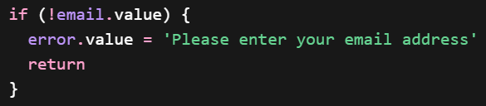

If the user hasn't entered an email address, display an error message immediately without communicating with the backend.
Step 2: Clear the previous error and enter the loading state.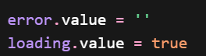
1.The front end calls the “Send Login Verification Code/Login Link” API
2. The backend sends an email to the user's email address
returning a verification code.
In case of success, the response might simply be:
{
“message”: “Login code sent”
}
or in case of failure, it might be:
{
“error”: “Invalid email address”
}
3.If successful, the OTP input field will appear, and the user will enter the 6-digit verification code.
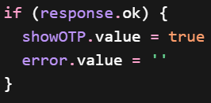

In other words, the six CAPTCHA input fields will only appear on the page after the backend returns a success response.
If the request fails, display the error message from the backend.

Close the loading screen regardless of success or failure
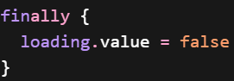
4.The front end calls the “Verification Code Validation” API to verify the 6-digit code

Step 1: Read the contents of the 6 input fields

Combine the six single-character input fields into a single string, such as “123456”.

Step 2: Check that the length is 6
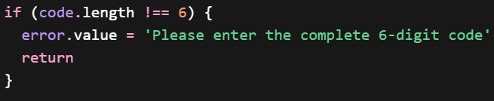

Step 3: Call the verification code validation API

Step 4: If the backend validation is successful
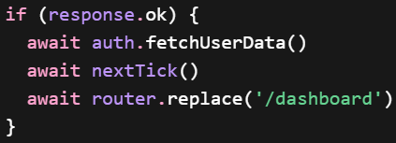
A. Retrieve user information
B. Wait for Vue to complete the reactive update
C. Redirect to the dashboard

And return:
Success:
{
“message”: “Login successful”
}
Failure:
{
“error”: “Invalid or expired code”
}

Step 5: If authentication fails
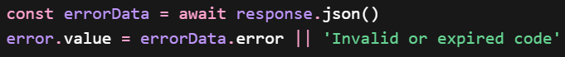

1.After successful verification, the front end retrieves the current user's information
2.Redirect the front end to /dashboard

1.1 API 1: Send Login Link/Verification Code: Sends a login link or verification code to the user's email address.
http://localhost:8000/services/send-login-code/
This is a URL, specifically the endpoint address that the frontend must access on the backend. This is the local development address, which may change after cloud deployment. It consists of an HTTP request, host address, and port number; “localhost” indicates the local machine. 8000 is the port the backend program listens on, and the /services/send-login-code/ path is the route for the backend interface responsible for this functionality. In other words, the frontend needs to access the “send-login-code interface within the backend service running on port 8000 on this computer.”
It is called in two places:
handleLogin()
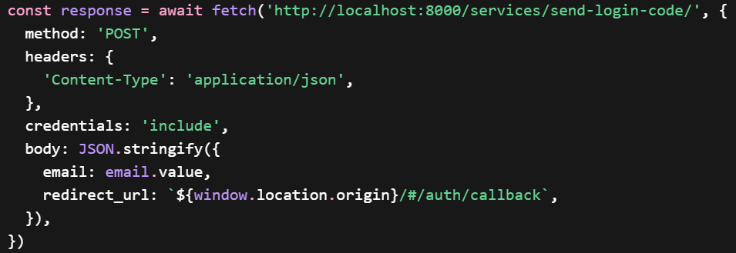
fetch(url, options)
The frontend sends an HTTP request to the backend API.
method: ‘POST’
Indicates that this is a POST request, typically used to submit data.
headers: { ‘Content-Type’: ‘application/json’ }
Tells the backend: I am sending data in JSON format.
credentials: ‘include’
This is crucial; it means the request includes cookies, and the session cookie returned by the backend can be saved by the browser. This login system likely uses cookie/session-based authentication, or at least partially relies on cookies.
body: JSON.stringify(...)
Converts the frontend JavaScript object into a JSON string to send to the backend.
{
“email”: “Email entered by the user”,
‘redirect_url’: “Current site/#/auth/callback”
}

resendCode() resends the verification code. If it wasn’t received or the email was entered incorrectly, call this method again to resend the verification code.
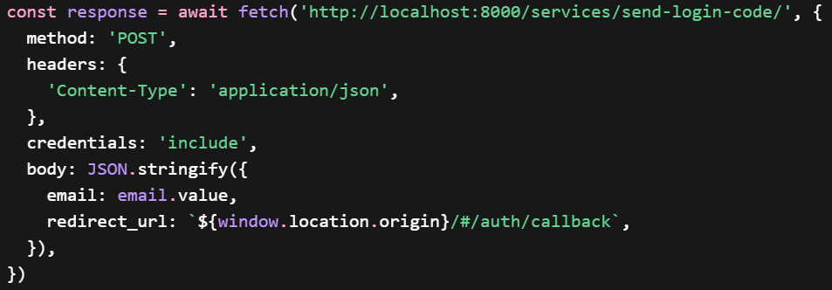

1.2 Interface 2: Verify OTP: Verifies the 6-digit OTP entered by the user.
http://localhost:8000/services/verify-login-code/
This is called only within the verifyOTP() method, sending the user's email address and the 6-digit OTP to the backend for verification.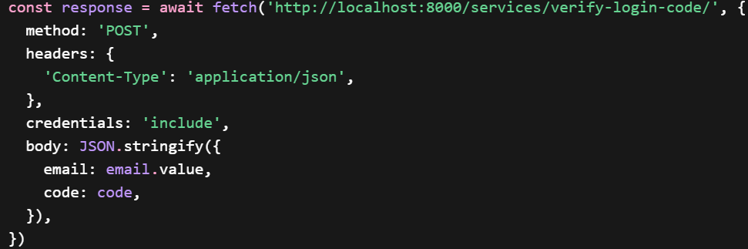

1.3 Indirect Interface 3: Retrieving Current User Information
await auth.fetchUserData()
After the OTP verification succeeds, the frontend fetches the current logged-in user’s information from the backend, such as:
User ID
User email
User role
Profile information
Logged-in status
Called after verifyOTP() succeeds.

await auth.fetchUserData()
After the OTP is verified, retrieve the current user’s complete information from the backend and update the frontend’s global login status.

1.4 Additional Features
1. Automatically move to the next field when entering the OTP
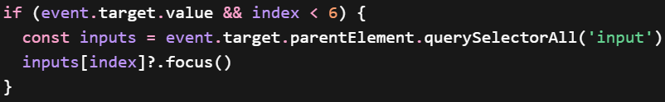
If a single character has been entered in the current input field and the user has not yet reached the sixth field, the focus should automatically move to the next input field. This will make it smoother for users to enter the 6-digit verification code.

- Resend verification code
Check if the mailbox is empty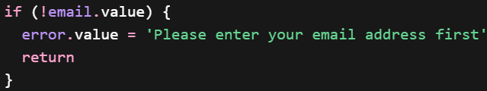
Call the verification code sending API again
Result
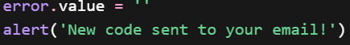

1.5 Front-end code
First section:
split-login
└── left-pane
├── bg-slideshow
│ ├── bg-slide * multiple
│ └── bg-overlay
└── left-inner
├── brand
│ ├── logo-icon
│ │ └── img
│ └── h1
├── custom-content
└── links
└── a

1.6 Front-end Optimization
1. Added role labels to the welcome area on the left side, allowing users to immediately see upon entering the page that the platform is designed for different roles such as Student, Mentor, Supervisor, and Admin.
2. Optimized the introductory text on the left side to better reflect the nature of the mentoring portal itself.
3. Added page transition animations on the left side.
4. Added a two-step navigation logic to the login page. The right-side card has been split into separate views for email input and OTP entry. Instead of appending the OTP section to the bottom of the original page, clicking “Send OTP” now directly navigates to a new OTP entry screen.
5. Added a “Back” button in the top-left corner of the OTP entry screen, allowing users to return to the email input page from the OTP page.
6. Added five-language switch buttons at the bottom and made them permanently fixed at the bottom of the login card so they do not disappear when switching between page steps. Regarding OTP code deletion: previously, users had to click each box individually to delete digits; now, they can move the cursor freely and use the Backspace key to delete continuously.
7. Adjusted the 30-second countdown logic so that the countdown is not reset when the user clicks “Back,” but is retained throughout the current login session.
8. Enhanced OTP verification code interaction logic: Added the ability to paste the code as input, and added the option to skip directly by pressing Enter.
9. Modified the logic for the “Send Verification Code” button: If the countdown has not ended, clicking “Send Verification Code” again on the email page will not actually resend the request, but will instead directly display the remaining countdown time.
10. Added email format validation logic to check the validity of the email address before sending the request, reducing invalid requests and improving the integrity of the front-end interaction.
11. Added a help entry at the bottom of the page, including a prompt to contact support and a link to the support email, making it easier for users to get help promptly when they are unable to log in.

2.DashboardPage
Essentially, the clickable content on this page consists mainly of RouterLink redirects, which take users to other pages rather than allowing them to complete tasks directly within the dashboard. No APIs are called directly.
2.1 Front-End Optimization
1. Redefine page positioning: Shift the page from its original focus as a “homepage navigation hub” to a format more akin to a production dashboard, enabling the homepage to not only display information but also directly support users’ key tasks and provide entry points for action.
2. Enhance the homepage’s task-oriented design: Move beyond simply displaying welcome messages, data cards, and standard navigation links to place greater emphasis on “what is the most important information right now” and “what should the user do next,” thereby increasing the dashboard’s practical value.
3. Refine Role Hierarchy Logic: Refine the page roles from the original broad distinction between “admin” and “non-admin” into three categories: student, teacher, and admin. This ensures that the content focus, functional entry points, and information structure for users of different roles better align with real-world usage scenarios.
4. Optimizing top-level user context display: We have added a more comprehensive display of user information in the top area. In addition to the username and track, we have included role information and implemented a unified fallback mechanism for all displayed fields to ensure the page displays correctly even when user information is incomplete.
5. Reworked the content logic of overview cards: Summary widgets are now dynamically generated based on role. Different users see different key metrics—for example, students focus on groups, events, and resources; teachers focus on mentoring sessions; and administrators focus on active groups, pending matches, and announcements.
6. Enhanced usability of the overview card: The top overview card now serves not only as an information display but also as a clear entry point to content, allowing users to navigate directly from key metrics to relevant modules, thereby improving operational efficiency.
7. Strengthened visual hierarchy of the homepage welcome area: The hero section received an overall visual enhancement, including more reasonable padding, title hierarchy, soft highlights, and subtle background decorations, making the page’s first screen more product-oriented and recognizable.
8. Optimize the first-screen reading experience: Clarify the hierarchy between welcome messages, supplementary notes, and status information so users can quickly understand their current role, status, and key tasks upon entering the page.
9. Enhance the visual impact of data cards: Standard data cards have been optimized into more prominent “clickable metric modules,” emphasizing numerical displays to help users quickly scan for key figures and corresponding explanations.
10. Optimize card interaction feedback: Added more natural hover effects, shadow changes, and background feedback to make cards feel more responsive during mouse interactions, further reinforcing the perception that “this is an actionable area.”
11. Unify card styling details: Added subtle borders, rounded corners, appropriate padding, and consistent white space to various modules, improving overall interface consistency and making the dashboard look more complete and professional.
12. Improved information scanning efficiency: By implementing a clearer three-tier structure of headings, values, and descriptions, we’ve reduced the cluttered feel of information and enabled users to locate key modules and critical content more quickly.
13. Added background image switching: We’ve introduced the ability to switch background images, enhancing page personalization and visual richness while making the dashboard more polished in terms of product presentation and user experience.
14. Enhance page stability and fault tolerance: Implemented more comprehensive fallback handling for displayed data to prevent blank pages,混乱, or display anomalies caused by missing user fields or incomplete API data.
15. Make the dashboard more closely resemble a real mentoring platform scenario: After overall optimization, the page is no longer just a generic management homepage but aligns more closely with the actual business logic of a mentoring platform, reflecting the real concerns and operational paths of different roles within the platform.

3. AppPage
3.1 Frontend Optimization
1. This update primarily adjusted the layout of the left-side navigation in App.vue, ensuring it remains fixed below the header when scrolling on desktop devices, is not obscured by the top bar, and can scroll independently when content is too long.
2. Optimized the interaction logic for the control panel in the user avatar area. Previously, the panel could only be closed by clicking the close button; now, it can be closed automatically by clicking in the blank area, using the Esc key, or when switching routes.
3. A calendar has been added below the left-side navigation bar. Administrators can edit events in the calendar, and all users can view the updated results, as well as holidays and daily reminders.

4. Router
4.1 Frontend Optimization
1. A configuration error related to the `group` parameter in router page redirects previously caused the dashboard to display modified content upon redirection; this issue has been resolved and redirects now function correctly.

5.Profile page
5.1
1. Upgraded the profile page from a static demo page to a dynamic functional page: The ProfilePage.vue component was improved so that it now displays the real information of the currently logged-in user instead of only showing static demonstration content.
2. Supported multiple user data structures: The profile page was updated to handle different possible user data formats, which improves compatibility and makes the page more robust when working with varying backend responses.
3. Enabled automatic retrieval of updated user information: The page can now automatically fetch and display updated user data, allowing profile information to stay more consistent with the current authentication state of the system.

